Plan your Project using the sequencing chart
Name/Class: Aline, Davina, Indi, Grace, Nidia 5C

Project Plan:
Simple machine: | Wheel & Axle
What can this simple machine do? | It helps to transport objects easily.
What idea can you think to develop this simple machine? | We can use a board then connect it with the wheel and axle.
What are the equipments and materials needed? | - Board(Indi)  - Table legs(Indi)  - Wheels & Axles(Grace)  - Nails(Indi)  - Screw(Grace)  - Drill(Davina)  - Hammers(Indi & Davina)
Plan your project here | Provide the tools and equipment to build the simple machine which is a moving table. Build the table at Family Outlet (Indi’s aunt’s store).  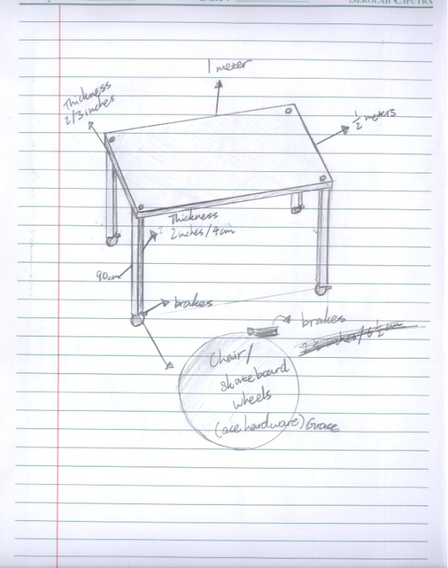
What are the results? | Success, we have built a moving table on which rolls around on wheels.
Could you evaluate your success/failures? | Success:  We have made the moving table together and it can move around properly.  Failures:  When we built the table we didn’t have much knowledge in building with wood so we made the table a bit crooked.

Type: chair wheels
2½.1 in/6½ cm

Wheels 4x

2 in/4 cm
90 cm
Table Leg
2/3 inches
Thickness
½ meter
1 meter

Board

