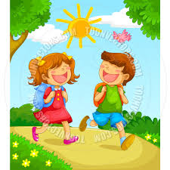
My Learning Journey
at:__________________

Picture of the place (factory/farm) | Raw materials/ food | End product
The process of production | Additional materials/food included in the process of production | Distribution process

My Learning Journey
at:__________________

The Production Process

Raw Materials/Food End Products

My Learning Journey
at:__________________

- What do I see at the farm/factory?
- How does the food/raw material processed?

