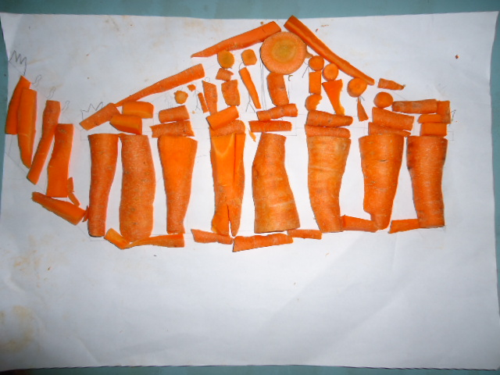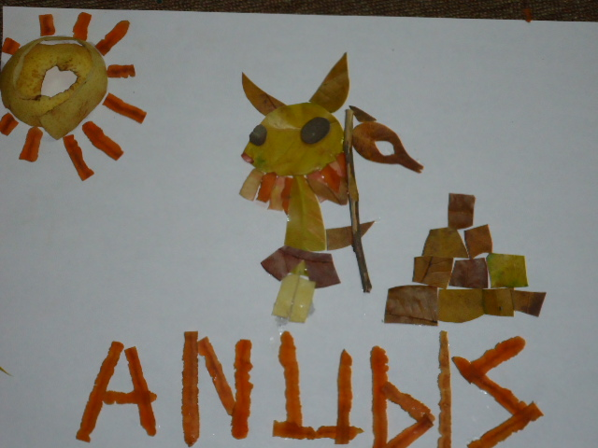
Parthenon-6D Denise’s group Egypt Myth-6C Ela’s Group
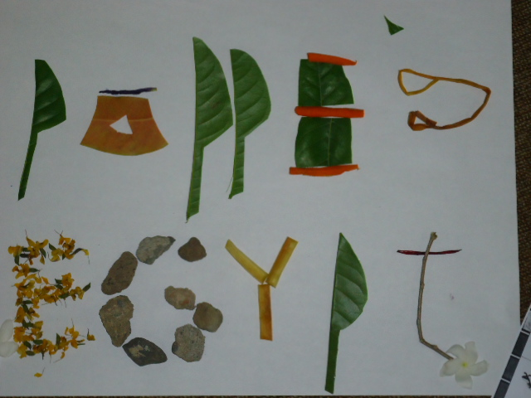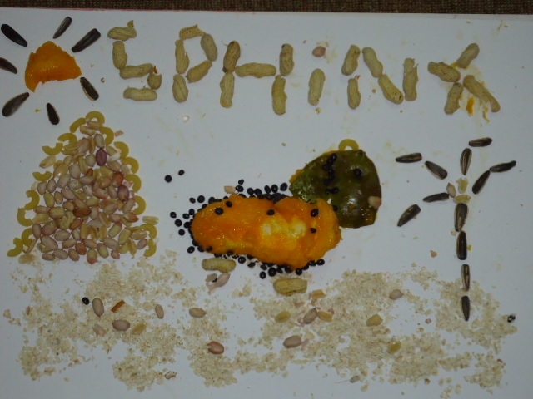
Heirogliph-6C Jennifer’s group Sphinx-6B keyla’s group
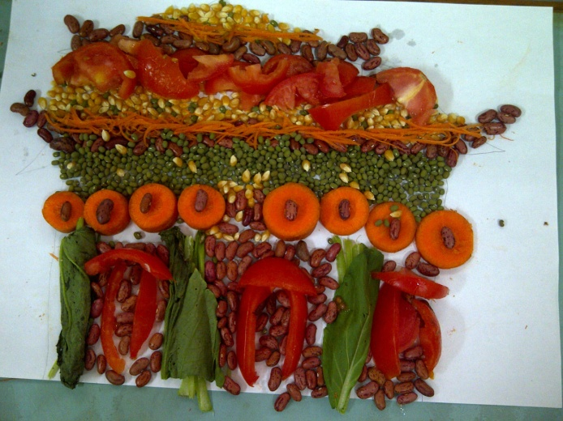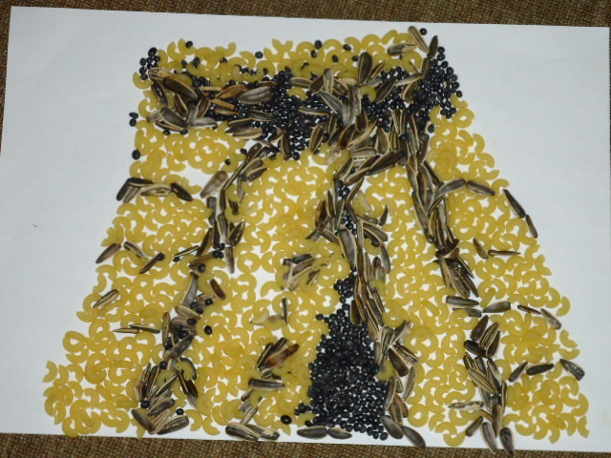
Forbidden City-6D Amelie’s Mayan Temple-6B Vanessa’s group
Group
In your group brainstorm your topic and use your thinking hats chart to gather the ideas
Group members/Class: Amelie,Christy , Karina, Kevin / 6D
Weaknesses | - What will we do if we cannot do it?  - How do we improve my skills to help our group?  - What should we do if the plan does not work?  Based on our experience, when problems arose we kept on trying our hardest. We worked together as a group and we were persistent to finish our task. Each of us relies on each other and we learnt from our group members’ strengths to improve our own. In the end, all of our plans worked out. However, we did have some plans to prevent the happening of problems. We planned to stop for a while and think of what we should do next.
Thinking/Reflection | - What do we learn from this learning?  - What are the exciting points when we learn about this?  - How does the teamwork happen in our group?  - What can we do to achieve the next step?  During this learning, we learnt how to improve our creativity during making our composed art. We also tried to be more punctual based on getting our work done on time especially for the composed art as it doesn’t last long. The most exciting part of this learning is when we made our composed art. It was very fun and challenging. In our group, the teamwork works well as we communicated well towards one another. We should reflect on what we had and try to make more plans before doing our tasks to prevent the happening of any kind of problems. Actually, we did not really use waste food to make our composed art but instead, we bought some new food. The only waste were the tomatoes. So we thought that we wasted some good food only to make the Forbidden City composed art. We felt bad that we wasted food that poor people would want and need, very much. The challenge was to use waste objects to make our composed art, and we still feel that we failed a little because we used some new food.
Gathering Information | - What is our topic?  - What do we want to do with my group?  - What information do we want to present at the end?  - How can we get the information?  - How can we relate the information and the art work?  Our topic is about the Forbidden City in Beijing, China. We will explore the Forbidden City especially the architecture and its colors. We want to express the beauty of the Forbidden City through our composed art. In the end, we want to present information about the architecture perspective of the Forbidden City. We will find varied resources from the internet and books. Our art work will express our information about the beauty of the Forbidden City’s architecture. We will make a good replica of the Forbidden City and show its architecture beauty.
Strengths | - How can we map our strengths?  - How do we share job and responsibility?  - When will we achieve the goals?  We will use our strengths in doing our tasks. Kevin and Amelie’s strengths are dealing with the technology and finding related information about the topic (Forbidden City). Karina and Christy are good in visual arts so they would be more in charge of the fruit and vegetable display. We will share jobs and responsibilities based on our strengths. So, we could do our jobs well because it’s what we are good at. We will try our best to achieve our goals at the end of this unit and after all of the learning process is done.
Feelings/Emotions | - What will we do if there is friction in our group?  - How can we accept differences?  - How do we measure our achievement?  Based on our group’s experience, there were no big frictions or problems. But we did try to communicate with each other to solve our small problems (Sometimes we did not come to the decision before we do our tasks). We accepted our differences by sharing and accepting other’s ideas. Based on our work, we will give it 9 out of 10. We think that our work could be better if we focused more to do our tasks. (Shape, colors, architecture, etc.)
New Ideas | - Can we think outside the box?  - Is it okay if we design or create something unusual?  - How can our ideas be accepted by others?  This is our work:  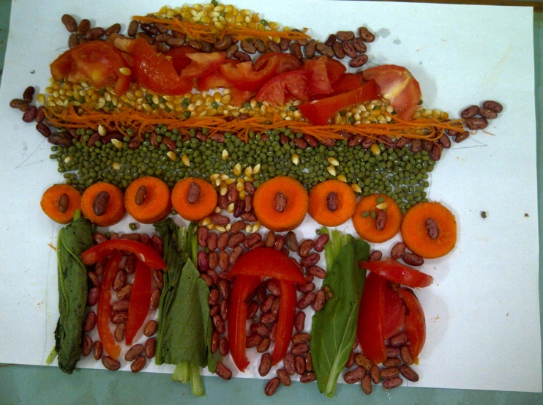  Referring to our task, we did try to think outside of the box. We tried to use a variety of materials for our composed art and make it as attractive and appealing as we can. Based on our opinion, we think that it is absolutely alright to create something unique and unusual as it is a creation of art. We could share our point of views to others to make them understand of what we wanted to express through our artwork.
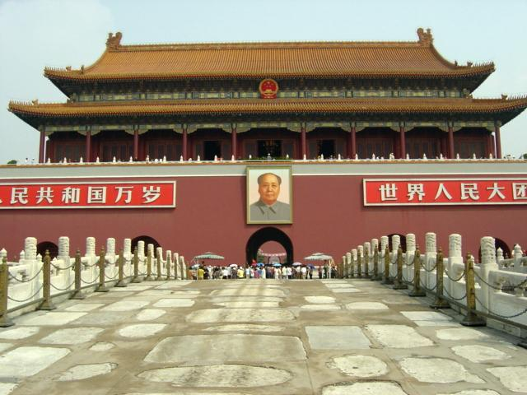
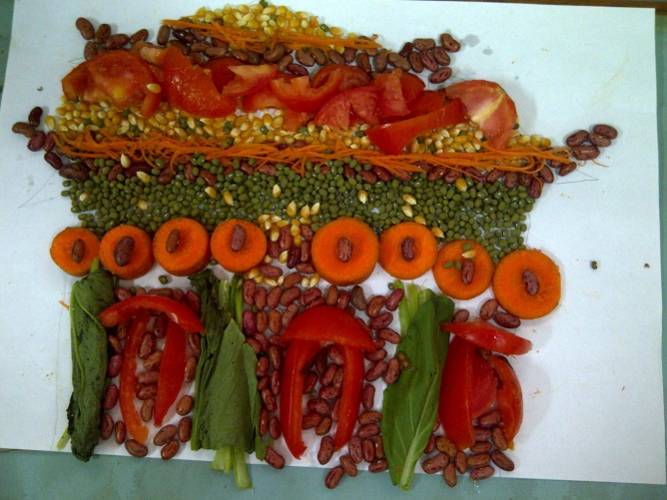
The Real Forbidden City
Our Composed Art of the Forbidden City

